Variables types:

There are a lot of variables types, here are some of them
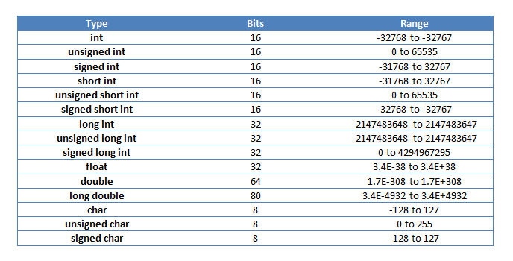
Variables are data that we give to the computer with a name so they will sort out a space will a specific format and store it in some mysterious place by flipping switches and creating binaries.
However, because computers can only use binary, it’s up to programmers to inform how many bits are in a group, what format those binaries are using, what to do with those bits.
Instead of doing all the complicated machine language, our senpais preprogrammed those common variable types for us, so all we have to do is put human words such as int, float , bool.
In this course, you will variables in almost every program, so try to remember these as fast as you can.
Range is the decimal range the data type can store. You can also find them in c++ by using the prebuild variables such as INT_MAX,INT_MIN
reference:https://msdn.microsoft.com/en-us/library/7fh3a000.aspx

Int:

- Represent integers, they must be whole numbers. If you were to assign a fraction number such as 5.999, 3.1415, c++ will automatically ignore all digits after the decimal point(not round up or round down), so 5.999 will become 5, 3.1415 will become 3.
- integers take reasonably small amount of memory, only 16 bits. Therefore, it’s frequently used in basic programming, it’s the smallest variable type to store numbers
- Normal integers has the range to -31768 to 32767, it can store most day to day values such as age, height, students in class etc

Float and double:
- Float is the short term for floating points, it can store fraction numbers. It takes double amount of memory than integers, but it also have a much bigger range, you usually won’t excess that.
- Use floating points only when necessary, for more memory use will take more time for the computer to process. Even though right now it won’t make that much of a difference, but it’s good practice and it’ll help you when doing bigger programs.
- Double is just a floating point with double the memory, thus much bigger range(not doubled range, it has double amount of digits in binary)

Char:
- Short for character, it can store one single character. To assign one, you put single quotation mark ‘ ’ around your character, such as ‘k’, or else the program will think k is a variable.
- Char takes little space, but when the user is inputting a character but somehow inputed more than one character (such as abcd), c++ will only accepted the first character (in this case it will be a, bcd will be ignored)
- If the character stored in a char type variable happens to be a one digit number and you are lucky, some version of c++ can accept this as a integer and do calculations with it, but it’s hardly practical.

String:
- String is a collection of characters, basically a lot of characters connected with order. For example people’s name is a string, building’s address is a string. To assign a string, you put quotation mark “ “ around your word
- At this point, try not let user input a string, errors might occur. String type variable are mainly used to store but not accept input. String type is created for convenience, so don’t do complicated stuff with it.
- When doing more harcore stuff, use c-style string, which will come up in a lesson

Bool:
- Short for boolean. It can only store true or false (1 or 0), it’s used by loops to determine should it run or not.
- You can assign value to bool using conditions:
  - (2 + 3 == 5) ⇐ true
  - (5 > = 6) ⇐ false
  - (123 != 5) ⇐ true
3) more about conditions and operators will be in one of the lessons

Const:
- Not a variable type itself, it’s used as a prefix to make a variable constant. A constant variable’s value cannot be changed in any way. Though values don’t randomly change by themselves, constant can prevent other programmers accidentally changed the value.
  - Const int x = 10
  - Const float pi = 3.14

Signed and unsigned:
- All variables are automatically created unsigned. Unsigned variables can store both positive and negative values whereas signed variables can only store positive value.
- Then why would we ever use signed variables since it can only represent positive numbers? It allows bigger range as one less bit is used to store the + or - signs.

Long and short:
- Can be the prefix of int or float. It’s used to double or halve the size of the variable. Won’t be used frequently or at all in this course.

So tired :(

